***Static LSP***

The implementation was done for the static LSP requiring of LER nodes, LSR nodes and the workstations. All these nodes were connected through the PPP_Sonet_OC3 cable. The primary LSP was covering the area from the **Dallas-Denver-New York**, which is marked in Blue. Back-up LSP routed from **Dallas-Austin-Miami-New York**, which is marked in Red. The traffic flow and IP ping traffic was created from User A to User B and the route was recorded.

**TOPOLOGY DIAGRAM:**

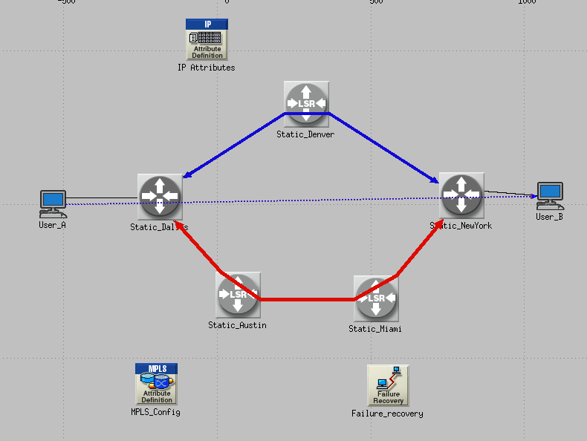

**The Observed output for Static LSP are as follows.**

**PRIMARY LSP TRAFFIC IN (PACKETS/SEC)**

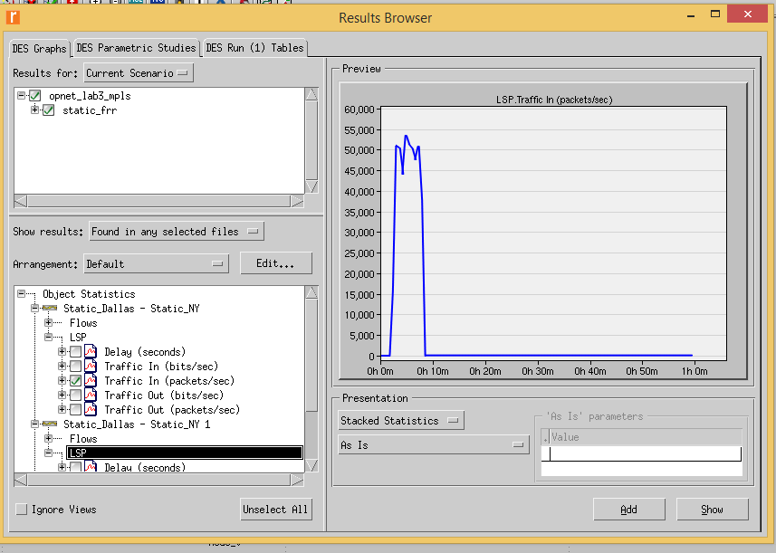

**BACKUP LSP TRAFFIC IN (PACKETS/SEC)**

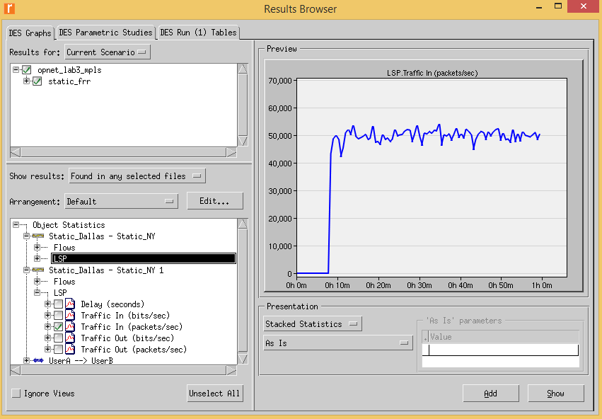

**USER TRAFFIC RECEIVED (PACKETS /SEC)]**

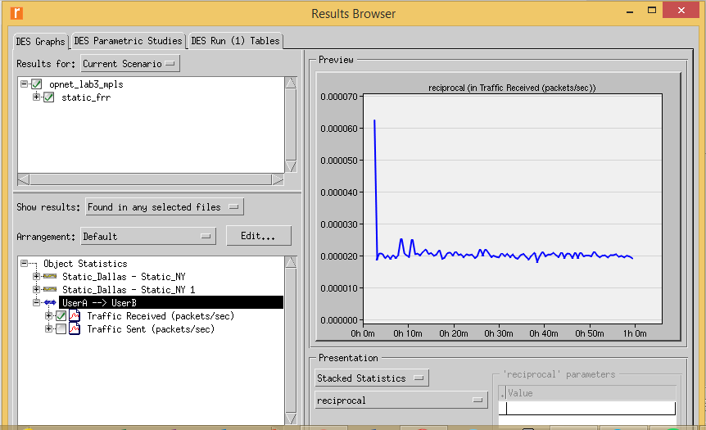

The above screenshots pasted are the output graph for the primary LSP, backup LSP and the user traffic. From the 1st graph, we can analyze that the traffic determined is for the primary LSP. In the graph we can analyze that after start of the packet transfer, at around 1-1.5mins we had a packet transfer of 50000 packets. And around 8-8.5 mins, we had an enormous drop in our packet transfer. At this very moment, our secondary LSP became active and took over from the primary LSP. But around 9-9.5 mins we had a packet transfer of 50000 packets, but we lost packets between 8.5-9th min. that was due to the switchover delay. We can see the User traffic sent from UserA to UserB. The output was taken in the reciprocal form.

The below attached screenshot shows the actual packet transfer process happening which can be seen in green colored line.

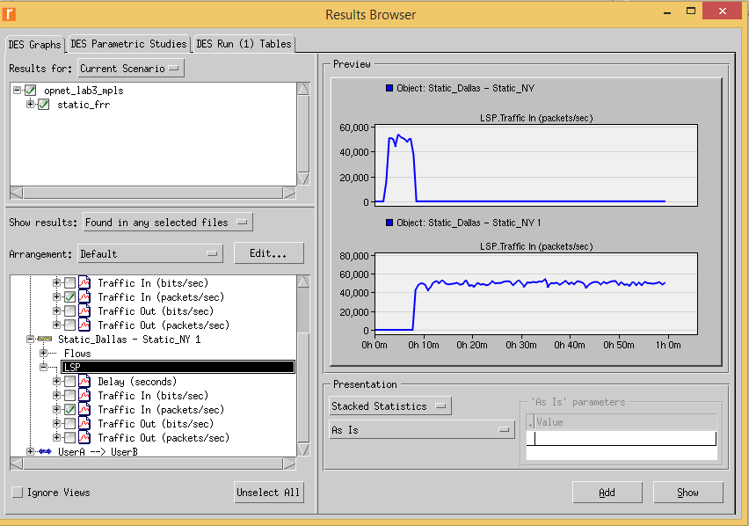

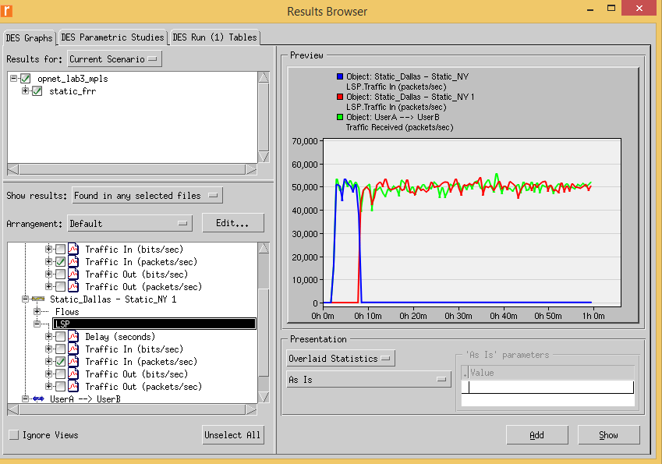

***Dynamic LSP***

In here, we just connected the **DALLAS-NEW YORK** through Dynamic LSP. After 500 seconds, the **DENVER** node was made failed/down.

**TOPOLOGY DIAGRAM:**

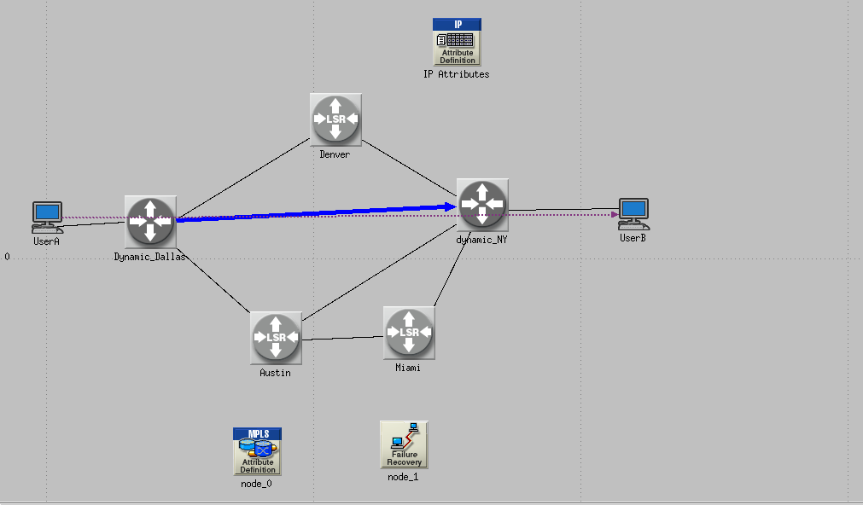

**The Observed output for Dynamic LSP are as follows.**

**DYNAMIC LSP TRAFFIC IN (PACKETS/SEC)**

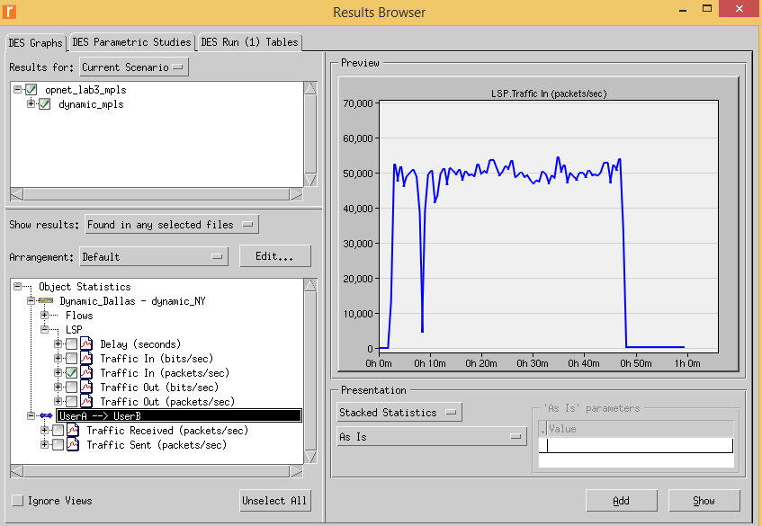

**USER TRAFFIC RECEIVED (PACKETS /SEC)**

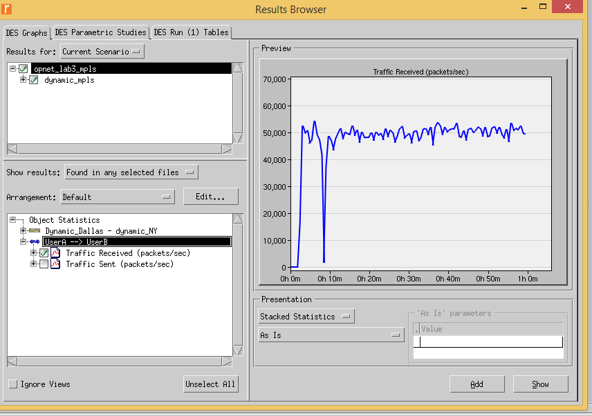

**PATH DETAILS FOR DYNAMIC LSP**

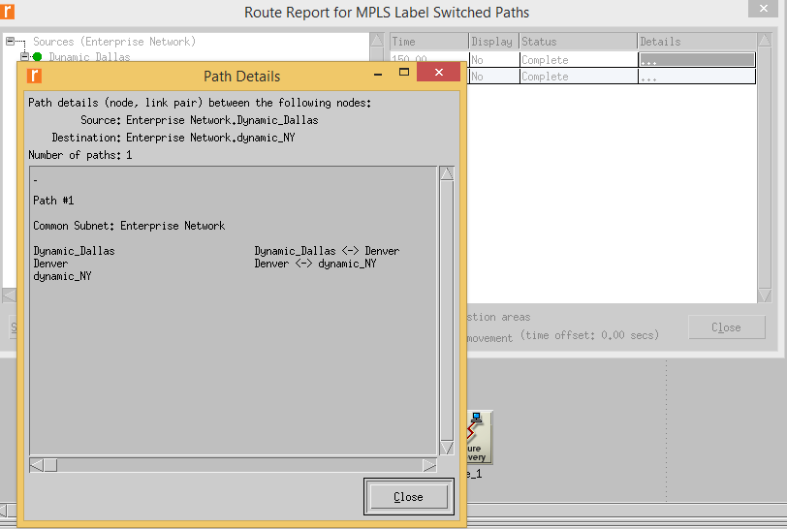

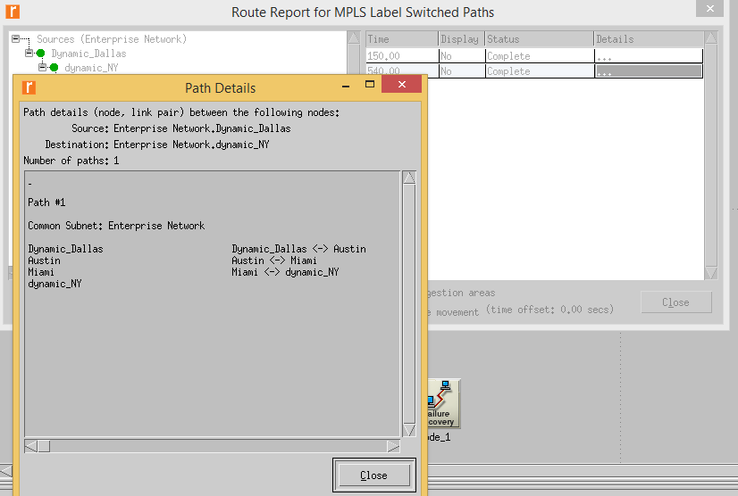

As we can see that the traffic reached more than 50000 packets at after 2 minutes of the start of packet transfer. At around 8th minute, we can see that there is a huge packet loss, that ranged from 50000 to less than 10000 packets. For this it was assumed that the **Denver** node failed, and henceforth, making the **Austin node up** to send traffic directly from **Dallas-Austin-New York**.

**Primary Path Details: DALLAS-DENVER-NY**

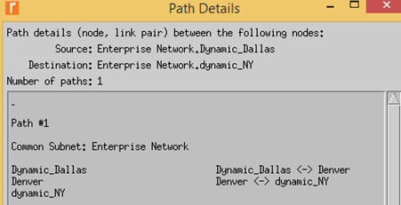

**When Denver node fails, the path details are as shown;**

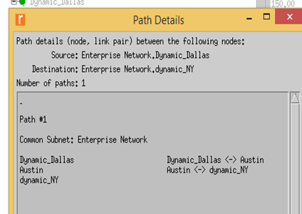

It can seen in the below snapshot presented that we have a continuous output after the Denver node failed and the backup path was taken from **DALLAS-AUSTIN-NEW YORK.**

